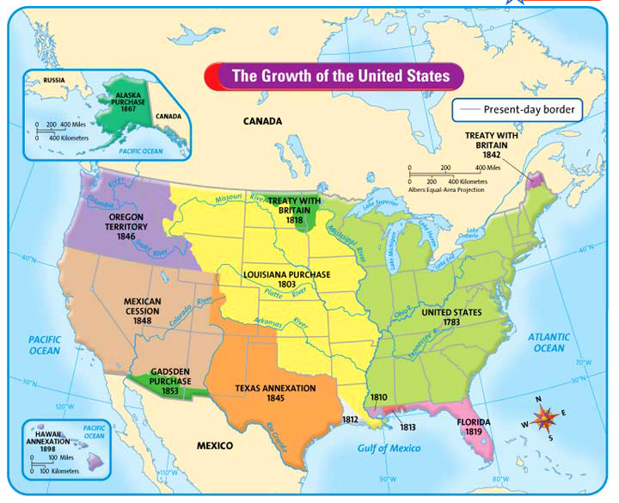

Louisiana Purchase- U.S. bought land from France & doubled the size of the U.S

Texas (the Alamo)- Texans wanted to be a part of America, not Mexico. They became a republic after capturing Santa Anna, and later added to the U.S. in 1845

Oregon (Oregon Trail)- began in Independence, Missouri and led to Oregon Country. (About 6 months) Arguments over this land with Britain, but we signed a treaty to solve the disputes.

Mexican American War- Dispute over the Texas & Mexican border. 1848, signed the Treaty of Guadalupe Hidalgo & created the border (Rio Grande River)

